**Java for Loop**

In computer programming, loops are used to repeat a block of code. For example, if you want to show a message **100** times, then rather than typing the same code **100** times, you can use a loop.

In Java, there are three types of loops.

* for loop
* [while loop](https://www.programiz.com/java-programming/do-while-loop#syntax-while)
* [do...while loop](https://www.programiz.com/java-programming/do-while-loop#do-while-loop)

This tutorial focuses on the for loop. You will learn about the other types of loops in the upcoming tutorials.

**Java for Loop**

Java for loop is used to run a block of code for a certain number of times. The syntax of for loop is:

for (initialExpression; testExpression; updateExpression) {

// body of the loop

}

Here,

1. The initialExpression initializes and/or declares variables and executes only once.
2. The condition is evaluated. If the condition is true, the body of the for loop is executed.
3. The updateExpression updates the value of initialExpression.
4. The **condition** is evaluated again. The process continues until the **condition** is false.

To learn more about the conditions, visit [Java relational](https://www.programiz.com/java-programming/operators#equality-relational) and [logical operators](https://www.programiz.com/java-programming/operators#logical).

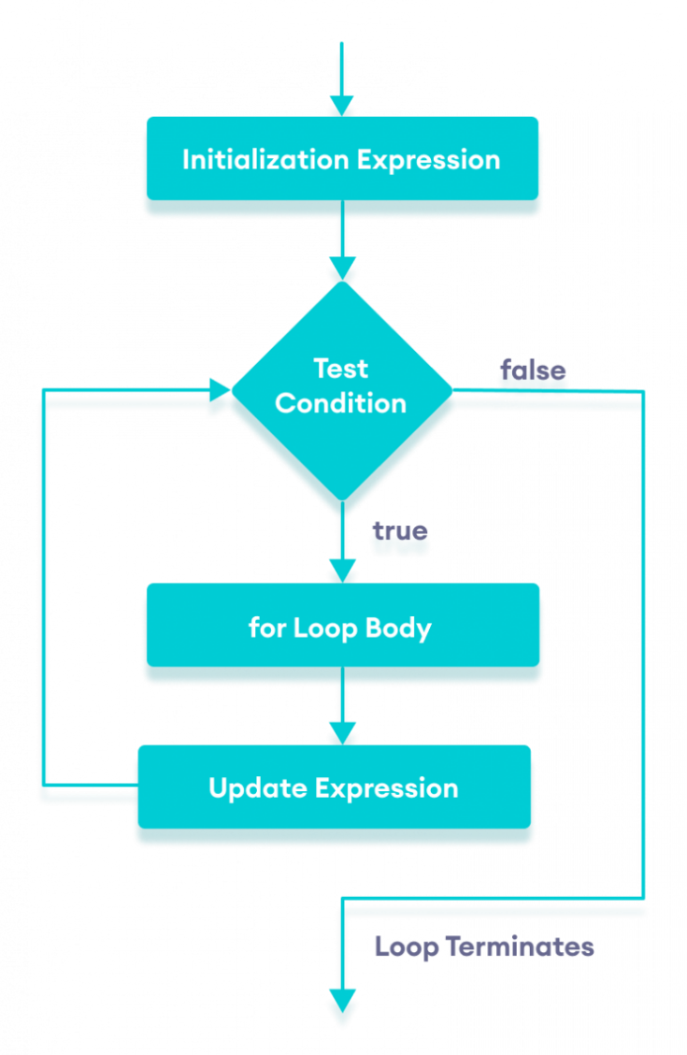Flowchart of Java for loop

**Example 1: Display a Text Five Times**

// Program to print a text 5 times

class Main {

public static void main(String[] args) {

int n = 5;

// for loop

for (int i = 1; i <= n; ++i) {

System.out.println("Java is fun");

}

}

}

[Run Code](https://www.programiz.com/java-programming/online-compiler)

**Output**

Java is fun

Java is fun

Java is fun

Java is fun

Java is fun

Here is how this program works.

|  |  |  |  |
| --- | --- | --- | --- |
| Iteration | Variable | Condition: i | Action |
| 1st | i = 1 n = 5 | true | Java is fun is printed. i is increased to **2**. |
| 2nd | i = 2 n = 5 | true | Java is fun is printed. i is increased to **3**. |
| 3rd | i = 3 n = 5 | true | Java is fun is printed. i is increased to **4**. |
| 4th | i = 4 n = 5 | true | Java is fun is printed. i is increased to **5**. |
| 5th | i = 5 n = 5 | true | Java is fun is printed. i is increased to **6**. |
| 6th | i = 6 n = 5 | false | The loop is terminated. |

**Example 2: Display numbers from 1 to 5**

// Program to print numbers from 1 to 5

class Main {

public static void main(String[] args) {

int n = 5;

// for loop

for (int i = 1; i <= n; ++i) {

System.out.println(i);

}

}

}

[Run Code](https://www.programiz.com/java-programming/online-compiler)

**Output**

1

2

3

4

5

Here is how the program works.

|  |  |  |  |
| --- | --- | --- | --- |
| Iteration | Variable | Condition: i | Action |
| 1st | i = 1 n = 5 | true | 1 is printed. i is increased to **2**. |
| 2nd | i = 2 n = 5 | true | 2 is printed. i is increased to **3**. |
| 3rd | i = 3 n = 5 | true | 3 is printed. i is increased to **4**. |
| 4th | i = 4 n = 5 | true | 4 is printed. i is increased to **5**. |
| 5th | i = 5 n = 5 | true | 5 is printed. i is increased to **6**. |
| 6th | i = 6 n = 5 | false | The loop is terminated. |

**Example 3: Display Sum of n Natural Numbers**

// Program to find the sum of natural numbers from 1 to 1000.

class Main {

public static void main(String[] args) {

int sum = 0;

int n = 1000;

// for loop

for (int i = 1; i <= n; ++i) {

// body inside for loop

sum += i; // sum = sum + i

}

System.out.println("Sum = " + sum);

}

}

[Run Code](https://www.programiz.com/java-programming/online-compiler)

**Output**:

Sum = 500500

Here, the value of sum is **0** initially. Then, the for loop is iterated from i = 1 to 1000. In each iteration, i is added to sum and its value is increased by **1**.

When i becomes **1001**, the test condition is false and sum will be equal to 0 + 1 + 2 + .... + 1000.

The above program to add the sum of natural numbers can also be written as

// Program to find the sum of natural numbers from 1 to 1000.

class Main {

public static void main(String[] args) {

int sum = 0;

int n = 1000;

// for loop

for (int i = n; i >= 1; --i) {

// body inside for loop

sum += i; // sum = sum + i

}

System.out.println("Sum = " + sum);

}

}

[Run Code](https://www.programiz.com/java-programming/online-compiler)

The output of this program is the same as the **Example 3**.

**Java for-each Loop**

The Java for loop has an alternative syntax that makes it easy to iterate through [arrays](https://www.programiz.com/java-programming/arrays) and [collections](https://www.programiz.com/java-programming/collections). For example,

// print array elements

class Main {

public static void main(String[] args) {

// create an array

int[] numbers = {3, 7, 5, -5};

// iterating through the array

for (int number: numbers) {

System.out.println(number);

}

}

}

[Run Code](https://www.programiz.com/java-programming/online-compiler)

**Output**

3

7

5

-5

Here, we have used the **for-each loop** to print each element of the numbers array one by one.

In the first iteration of the loop, number will be **3**, number will be **7** in second iteration and so on.

To learn more, visit [Java for-each Loop](https://www.programiz.com/java-programming/enhanced-for-loop).

**Java Infinite for Loop**

If we set the **test expression** in such a way that it never evaluates to false, the for loop will run forever. This is called infinite for loop. For example,

// Infinite for Loop

class Infinite {

public static void main(String[] args) {

int sum = 0;

for (int i = 1; i <= 10; --i) {

System.out.println("Hello");

}

}

}

[Run Code](https://www.programiz.com/java-programming/online-compiler)

Here, the test expression ,i <= 10, is never false and Hello is printed repeatedly until the memory runs out.